**Ed’s Robot Project – Part 5**

**After 15 days, the analog infrared sensors finally arrived from WaveShare from China.**

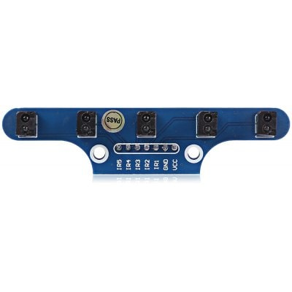

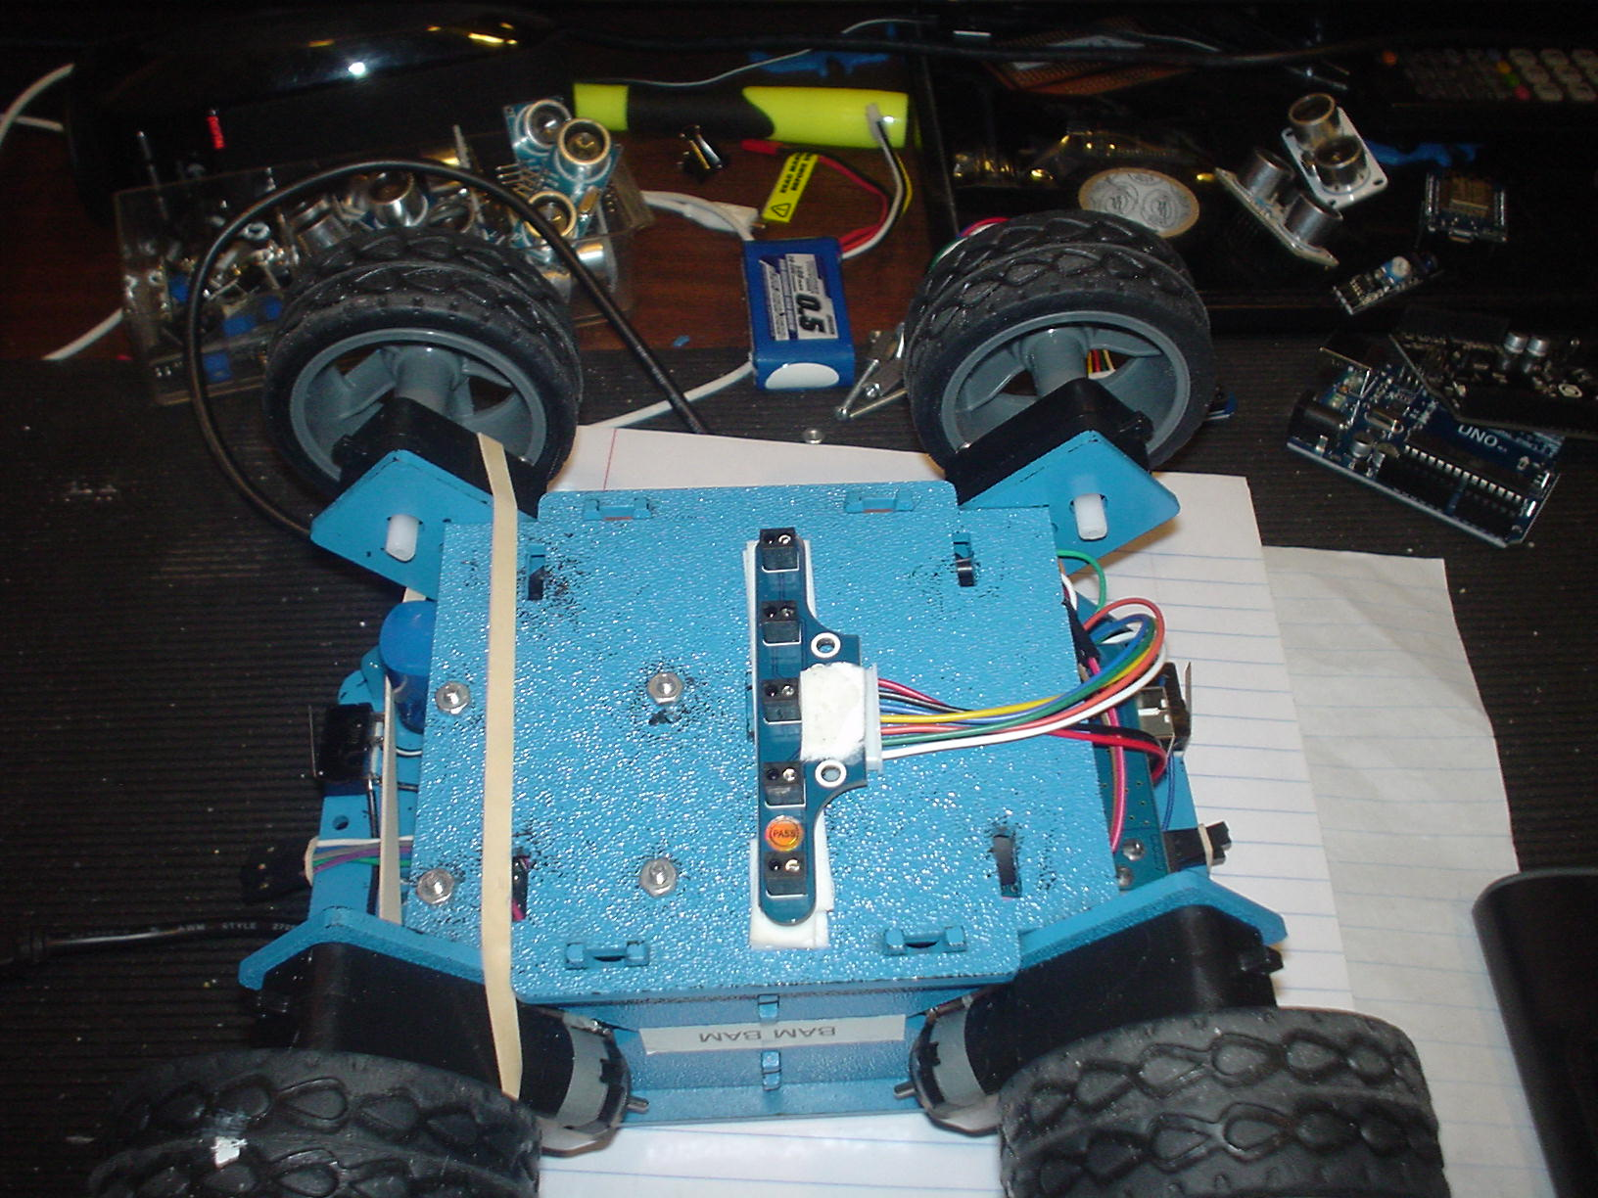

**The analog IR array came with its own wire harness, making it easy to install.**

The previous, stand-alone digital sensors had trim-pots, allowing each sensor to be tuned for sensitivity and distance. The new sensors have no such adjusting, but the WaveShare site had a formula for normalizing the sensor values and an algorithm to return a position number using a weighted average function. The examples were flawed and, unfortunately, the library for the array had been pulled from their site. I received no response from my email inquiry, so I had to roll my own sensor libraries. However, from the first trial run, the improvement in performance was noticeably improved. Once the PID constants were in the proper range, the robot could follow a straight line - as well as both right-hand and left-hand turns!

The operation is a little “squirrelly” (as can be seen in the you-tube video: <https://youtu.be/1PM_p28iVLM> ) but some planned improvements should smooth it out somewhat:

The PID values generated often result with a motor speed value in the “dead zone” for that set of motors. For example, the right wheels do not spin forward for a value less than 60 or backward for a value less than 70. If the speed for the right wheels falls within this range, the robot will turn too far or too little depending on the value sent to the left wheels.

The solution to this part of the puzzle is to use the ratio from the calculated values for the left and right wheels, adjust any dead zone value to its nearest operational value and apply the ratio to determine the proper value for the opposite wheels. My coffee shop barista provided me with this solution. Fortunately for me, Paul was a rocket scientist (NASA).

There is also a clipping issue, where a calculated value exceeds the 255-maximum motor speed. Other issues have to do with setting optimal delay durations. A minimum delay for the analog sensors to reset is necessary as occasionally the sensor read function returns no values at all. Also, the duration to run the motors after calculating the power to apply needs to be tweaked.

WaveShare says better resolution can be obtained from this IR sensor array by using an analog-to-digital converter rather than the Arduino analog inputs. They have one available but the instructions for use and supporting libraries for this component are also missing from the site!

So, I plan on smoothing out my turns for the PID algorithm but may next move to hall-effect sensors to track a magnetic wire. This technology returns the exact distance to the wire and direction (using two sensors) and allows correcting direction by changing the turning radius and setting the duration of the turn – rather than PID.

If I get some time I think I’ll move all this stuff - and the associated ‘C’ code – to GitHub and maintain it there. If so, this will be the last email robotics update.

**New toys in my robotic shopping cart:**

Top of Form

[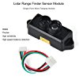](https://www.amazon.com/gp/product/B075V5TZRY/ref=ox_sc_act_image_2?smid=A1N6DLY3NQK2VM&psc=1)

* [MakerFocus Lidar Range Finder Sensor Module Single-Point Micro Ranging Module Pixhawk Compatible with Cable](https://www.amazon.com/gp/product/B075V5TZRY/ref=ox_sc_act_title_2?smid=A1N6DLY3NQK2VM&psc=1)by MakerFocus

[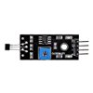](https://www.amazon.com/gp/product/B00K8OWIFI/ref=ox_sc_act_image_3?smid=A1CJB5SYI9X4XC&psc=1)

* [SainSmart Hall Effect Sensor Switch Magnetic Detector for Arduino UNO R3 Motor](https://www.amazon.com/gp/product/B00K8OWIFI/ref=ox_sc_act_title_3?smid=A1CJB5SYI9X4XC&psc=1)by SainSmart

[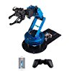](https://www.amazon.com/gp/product/B074T6DPKX/ref=ox_sc_sfl_image_1?ie=UTF8&psc=1&smid=A1K1UK7O5KP6WQ)

* [LewanSoul LeArm 6DOF Full Metal Robotic Arm with Servo, Controller, Wireless Handle, Free PC Software and APP, Video Tutorials for Arduino Starter](https://www.amazon.com/gp/product/B074T6DPKX/ref=ox_sc_sfl_title_1?ie=UTF8&psc=1&smid=A1K1UK7O5KP6WQ)by LewanSoul

Bottom of Form